RESOLUTION NO.__________

RE: CERTIFICATE OF APPROPRIATENESS UNDER THE
PROVISIONS OF THE ACT OF THE PENNSYLVANIA
LEGISLATURE 1961, JUNE 13, P.L. 282 (53
SECTION 8004) AND BETHLEHEM ORDINANCE NO.
3952 AS AMENDED.

WHEREAS, it is proposed to install a 20” x 8” neon OPEN sign on the windows and to add signage to the new black awnings at 201 Mechanic Street.

NOW, THEREFORE, BE IT RESOLVED by the Council of the City of Bethlehem that a Certificate of Appropriateness is hereby granted for the work.

Sponsored by: (s)

(s)

ADOPTED BY COUNCIL THIS DAY OF

(s)
President of Council

ATTEST:

(s)
City Clerk

HISTORIC CONSERVATION COMMISSION

CASE # 527 – It is proposed to install a 20” x 8” neon OPEN sign on the windows and to add signage to the new black awnings at 201 Mechanic Street.
OWNER/APPLICANT: Anthony Bennicas / Edgar Hernandez

The Commission upon motion by Mr. Evans seconded by Mr. Loush adopted the proposal that City Council issue a Certificate of Appropriateness for the proposed work described herein:

- The proposal to install a 20” x 8” neon OPEN sign on the windows and to add signage to the new black awnings at 201 Mechanic Street was presented by Edgar Hernandez.

- The awnings, approved by HCC in October 2014, will have signs added to them. The signage will read “Oliverio’s” on the slope of the awning and “Pizza, Paninis, Salads” on the valance.

- All lettering will be a sans serif font, as proposed, and warm white in color. The size of the lettering will be as shown on the drawings submitted.

- The neon OPEN sign may be installed as proposed, but it may not flash or blink.

- The proposed motion was unanimously approved.

CU: cu
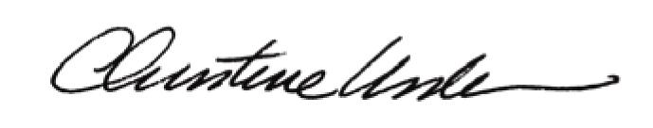

By:

Date of Meeting: December 15, 2014 Title: Historic

